**To:** Jie Yang  
**From:** Team 5, EE-286 Section 1Mason Gerace, Felecia Hildebran, Joshua Pollock, Taylor Yee  
**Date:**  November 13, 2018 **RE:** Project 3 - Update Memo 1

**Assignment:** The team will submit a memo detailing the progress made on this project to date. This will include a Gantt chart updated to reflect any changes in the scheduling. In particular, the Gantt chart must breakdown the tasks involved in the circuit construction (at least two or three individual tasks) and coding phases of the project. The original Gantt chart will be presented along the revised chart with detailed annotations of the changes. Also include a WBS with team assignments and justification for any changes. Be sure to check the project introduction memo for more specifics regarding this deliverable. This will be due November 13, 2018 at 11:59 pm.

The teams will submit a memo with:

1. Background research to determine the state of the art and/or possible ideas, complete project description including all specification and requirements the machine will meet.
2. The requirements and specifications must be developed in detail by the team – what will your device do? (Bulleted format!)
3. The requirements must be “abstract, verifiable, unambiguous and traceable” as discussed in Chapter 3 of the text.
4. A list of constraints
5. A Gantt chart with any revisions necessary
6. A WBS for the project.
7. Include a minimum of two rough sketches. (The sketches must be legible and informative!)

**Introduction:**

The team is submitting a memo to update the TAs and Professor Yang on progress made for project 3 so far. The memo will include background research the team has done for the project, as well as a complete requirements, specifications, and constraints list. Additionally, revised versions of the team’s Gantt chart and WBS, rough sketches, and a tentative list of parts needed will be presented.

**Background Research:**

* To make the rover move, our team looked into several types of motors, including DC, stepper, and servo motors. These motors differ in their functionality, and therefore we had to do research on which would best fit our design’s needs. Servo motors are extremely precise, but only rotate through a range of (usually) 0-180°. Stepper motors rotate beyond 180°, but require more programming, and separate power sources for each motor, since the Arduino cannot provide enough to power more than one. DC motors are built for faster rotations, such as in commercial fans and RC cars, and are continuous rotation models that are controlled by PWM (pulse width modulation).
* To detect the presence of objects, our team knew we needed a motion detector or sensor of some sort. One that we researched was an ultrasonic sensor, such as the HC-SR04. This sensor works in the same principle as bats do with echolocation - sending out a wave and detecting based on the waves that are refracted and ‘bounced back’ to the receiver module of the sensor. The HC-SR04 has adjustable ranging distances and requires 4 pins - 5V, GND, and two analog I/O pins.
* In order to generate noise for our rover, we looked into different types of buzzers. One type we researched was the piezo buzzer, which comes in most Arduino starter kits. There are two main types: active and passive buzzers. Active buzzers work by applying a DC voltage source, and then the buzzer generates sounds using an internal oscillator. Passive buzzers, on the other hand, require more programming to generate tones, but as such, the programmer can exercise more control on what tones play, as well as their frequency. In general, however, these require two pins: a power/input source, and GND.
* To operate our rover, we will need wheels of some sort. To that end, we looked into using the MakerLab at Cline Library at NAU to 3D-print some wheels. In order to 3D-print using the MakerLab, several types of software can be used for the design - such as Tinkercad, SolidWorks, and AutoDesk. Additionally, a 3D scanner can be used to scan a pre-existing object. One note that we will have to keep in mind is that the MakerLab will only accept designs with millimeters as the unit.

**Requirements/Specifications and Constraints:**

* Requirements/Specifications:
  + Must move autonomously
  + Activates LEDs to signal how close the rover is to an object
  + Stops and changes direction when objects are detected within a certain distance of the front end
  + ‘Honks’ piezo buzzer as rover approaches an object
* Constraints:
  + Cost - while our team can spend money on this, we are trying to avoid having to do so as much as possible
  + Must utilize the Arduino
  + Must have at least two motors
  + Must have at least 3 sensors, at least two of which cannot be mechanically activated

**Gantt Chart:**

The original and updated gantt charts (figures 1 and 2) can be seen on the next page.

The following updates were made to our Gantt chart:

* Changed the timeframe for working on the Gantt and WBS charts to finish by November 5th instead of November 7th
* Changed the date of deciding on the milestone to November 6th
* Changed the timeframe for working on the Decision matrices to begin on November 5th and end by November 8th
* Changed our timeframe for working on research to end by November 12th
* Changed our timeframe for working on updating the Gantt and WBS charts to end by November 20th
* Changed our timeframe for building and testing to begin on November 8th and end by November 28th
* Added three new tasks under build and test
  + Added building and programming ultrasonic sensor to begin on November 8th and end by November 28th
  + Added building and programming motors to begin on November 11th and end by November 28th
  + Added building and programming LEDs and buzzer to begin on November 13th and end by November 28th
* Changed timeframe to work on schematic(s) and bill of materials to end by November 28th

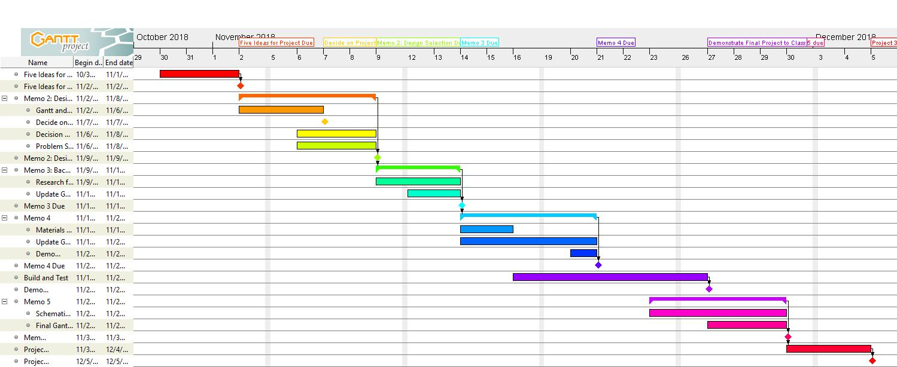

**Figure 1: Original Gantt Chart**

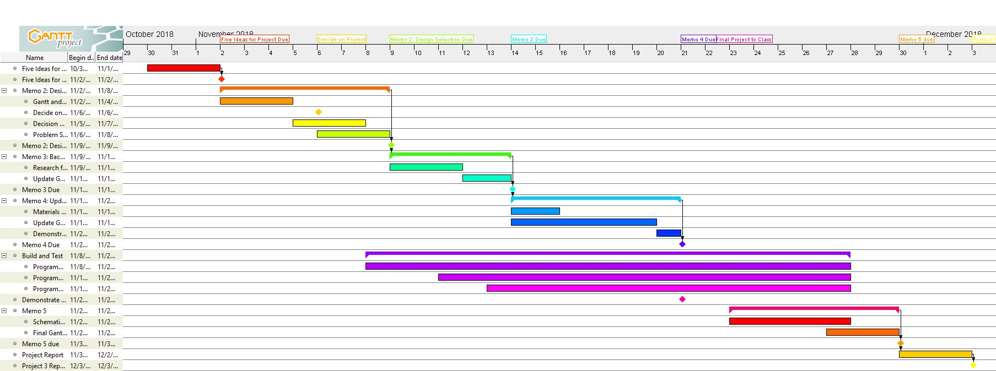

**Figure 2: Updated Gantt Chart**

**WBS:**

The following updates were made to our WBS Chart:

* Design selection memo was marked as completed
* Update and materials memo was marked as “in progress”

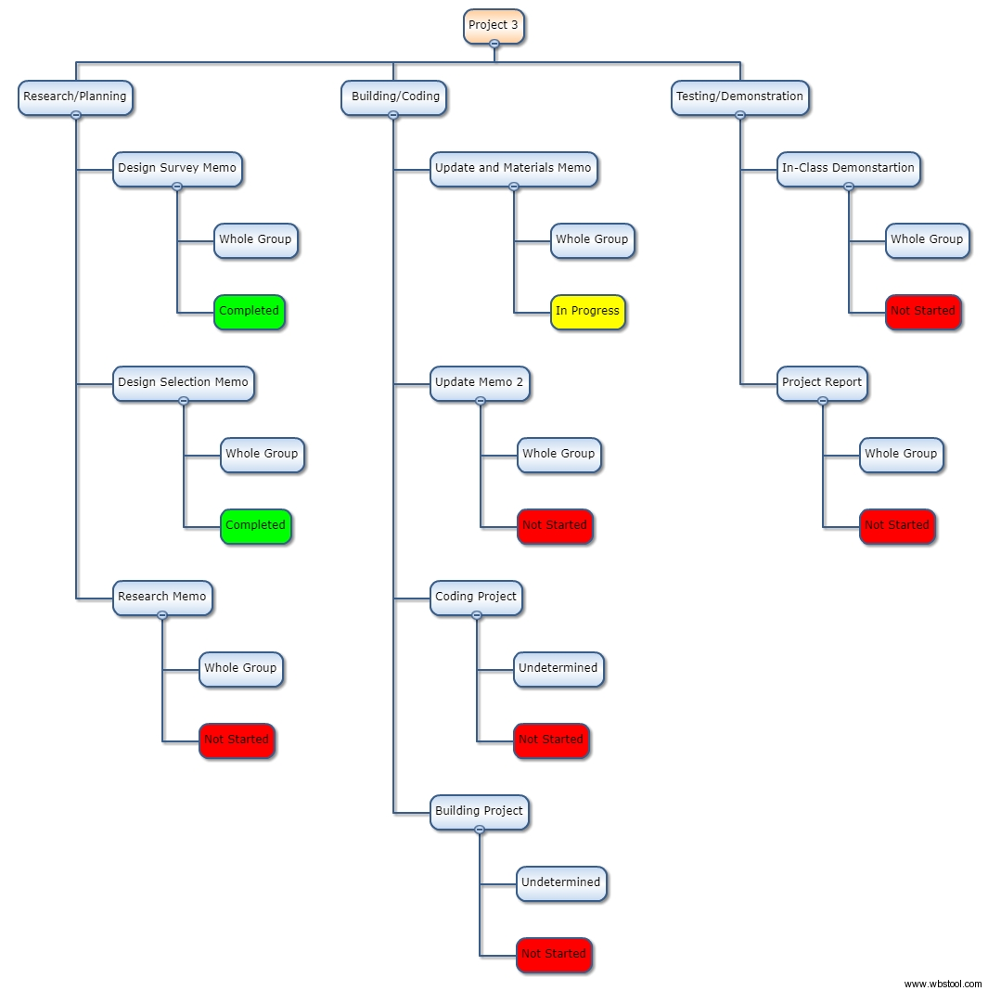

**Figure 3: Updated WBS Chart**

**Sketches:**

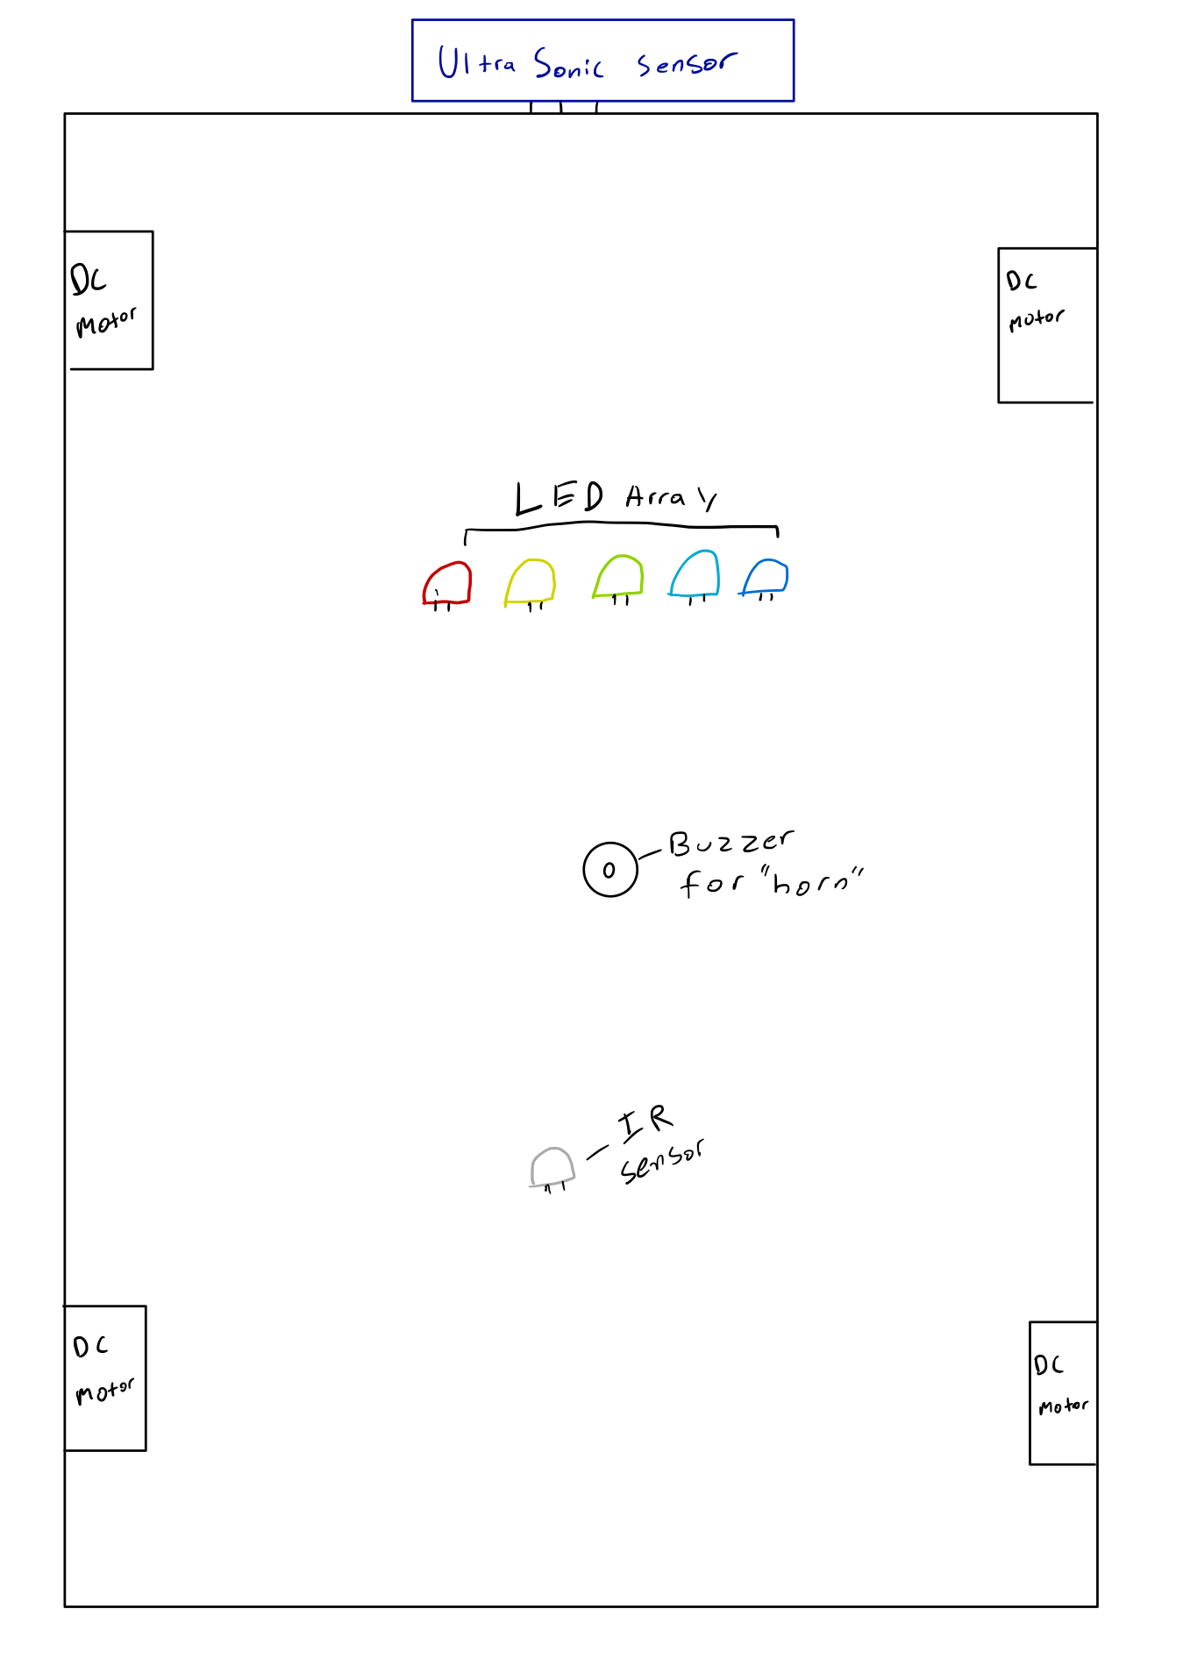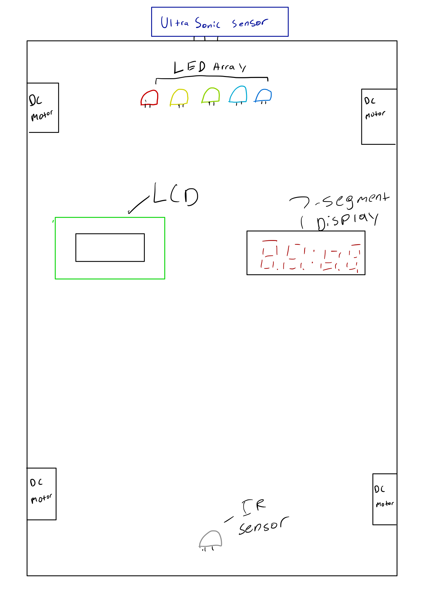

**Conclusion:**

In this memo, our team presented some of the background research we have done for this project, a more detailed list of requirements and constraints, and updated Gantt and WBS charts. We also have included sketches to detail how some of our team’s design will come together to operate the rover. Moving forward, these sketches will serve as a blueprint for building our rover, and the Gantt and WBS charts will help our team to stay organized and on track to complete this project in the time frame allotted.

**Attachments:** none